**OUTLINE**

~ Map Interface ~

Layer1: area divider 1 (base on south-north etc)

Layer2: area divider 2 (base on distance to campus)

Layer2: house price heat map

Layer4: detail info map (price, distance, etc of each apartment)

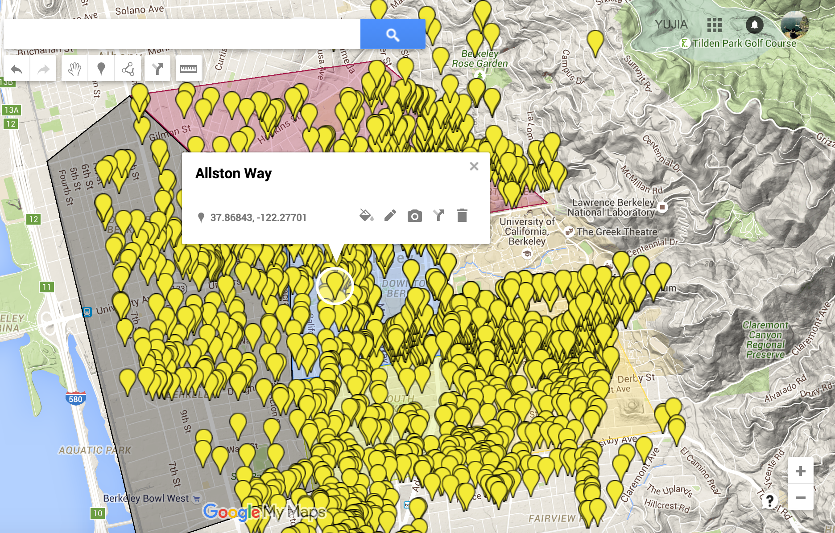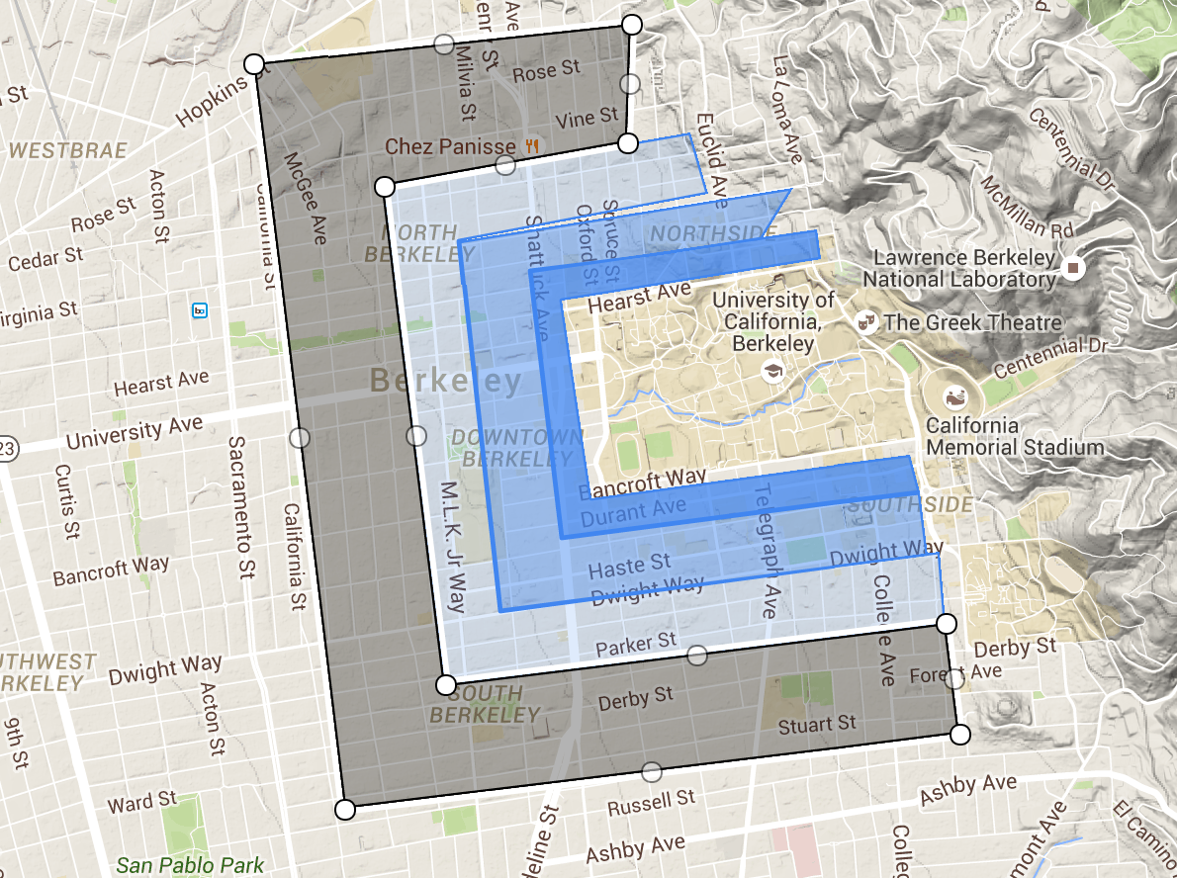

~ House price analysis ~

- Internal

room size, #Bathroom, #Shared rooms

- Distance from campus

Make

- Living quality

(within 2 miles)#Restaurants, #Place opened at night, #cafe, distance to the closest grocery

- Summary

(Optional: crime, transportation)